**31. Design PDA using simulator to accept the input string a nb n**

**AIM:** To design PDA using a simulator to accept the input string anbn.

**TRANSITION DIAGRAM:**

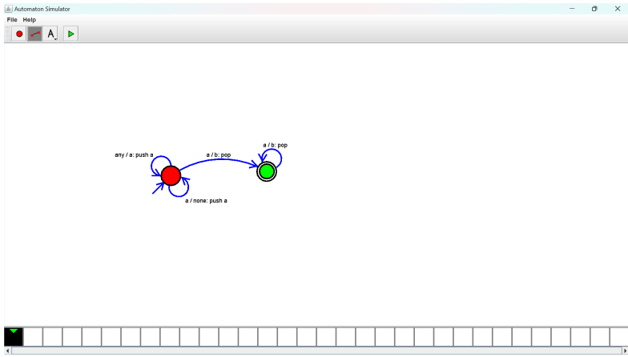

**RESULT**: Hence designing PDA to accept the input string a nb n